PEACEFUL BAY PROGRESS ASSOCIATION INC  Peaceful Bay WA 6333  ABN: 54389092839 www.peacefulbayprogress.org.au  Committee Meeting Minutes  for Sunday 5 April, 2020 | 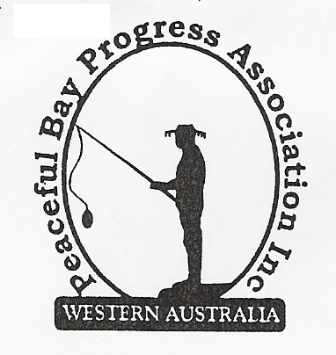

MEETING CANCELLED DUE TO COVID-19 RESTRICTIONS

All business to be presented at next possible meeting.

Present:

Apologies:

1. Confirmation of Minutes from previous meeting 3 March, 2020

Moved: 2nd – Accepted and carried by all.

2. Business Arising: All items covered in general business.

3. Correspondence:
IN:
3 Mar - Claire Thompson Special Council meeting minutes 3 March now on Website.
11 Mar – Claire Thompson Council meeting Agenda 17 March attached.
23 Mar – Sue Mearns SoD Council meeting Minutes 17 March attached.
27 Mar – Email from Best Office Systems re work operations during Covid-19 restrictions.
24 Mar – Email from Gail, NRRA with Information updates and flyers from Shire of Denmark
regarding Covid-19
OUT:
3 Apr - Letter of appreciation emailed to David King and SoD for basketball court resurfacing.

Moved: 2nd - Accepted/Endorsed.

4. Finance Report:
All proceeding to budget. .

Moved: Katie Eddington 2nd - Accepted/Endorsed.

5. Maintenance Report:

6. General Business:

Basket Ball half court has been resurfaced.

Easter Celebration/Festival BBQ is now cancelled due to Covid-19 bans. Could re-schedule
something similar when bans are lifted.

Items from the floor

7. Other Business

8. Meeting closed: Next Meeting: Sunday 3rd May, 2020

