PEACEFUL BAY PROGRESS ASSOCIATION INC  Peaceful Bay WA 6333  ABN: 54389092839 www.peacefulbayprogress.org.au  Committee Meeting Minutes  for Sunday 3 May, 2020 | 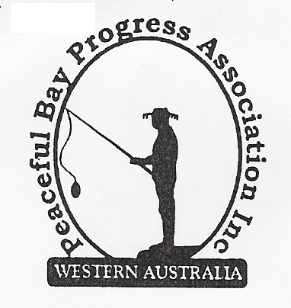

Meeting Opened: 9.10 am

Present: Hayden Jones (President), Katie Eddington (Treasurer), Mavis Jones (Secretary), Leanne Taylor, Reg Radford, Tony Armstrong.

Apologies: Graeme Liddelow (Vice President), Callum Baxter, Shannon Armstrong, Gill Irvine, Janine Phillips.

1. Confirmation of Minutes from previous meeting 2 March, 2020 (April meeting cancelled)

Moved: Katie Eddington 2nd Leanne Taylor – Accepted and carried by all.

2. Business Arising: All items covered in general business.

3. Correspondence:
IN:
3 Apr – email from Claudia Simpson SoD re Denmark Connected Community program.
3 Apr – email from David King thanking PBPA for letter of appreciation.
4 Apr – email from Shannon with photo of basketball court resurfacing.
14 Apr - email from Claire Thompson re Agenda of Council Meeting 21 April on website.
14 Apr – email from NRRA with information of Federal Government Drought Relief Funding
through St Vincent De Paul Society.
15 Apr - email from NRRA re saving the Nornabar and their chefs.
20 Apr – email from Ray and Julie Benson with attached letter re Irwin Inlet opening.
29 Apr – email from DCRC re services and info on Volunteer Week 18th to 24th May.
29 Apr – email from Claire Thompson re Minutes of Council meeting 21 April on Website.

OUT:
28 Apr – email to Ray and Julie Benson advising their correspondence will be put on our agenda
for discussion.

Moved: Leanne Taylor 2nd Tony Armstrong - Accepted/Endorsed.

4. Finance Report:
All proceeding to budget.

Moved: Katie Eddington 2nd Leanne Taylor - Accepted/Endorsed.

5. Maintenance Report:
The D Latch for the small gate into the Oval has been purchased and Katie to contact Jeremy
to arrange fixing.
The duplicates of the “No Vehicles Beyond This Point” on the bollards to be removed and
stored in the Les Carpenter shed for use if the remaining sign is washed away over the coming
winter period. This was the original intention of the PBPA committee when the duplicates were
sourced.

6. General Business:
Irwin Inlet opening. The correspondence received from Ray and Julie Benson was
discussed. Tony Armstrong read out notes from Shannon Armstrong on the issue and
Shannon will email the Committee with a submission to Council and our Ward Councillors to
have the opening level raised to protect the health and future viability of the Inlet.
The possibility of another meeting between the original representatives and the Shire was
raised and will be considered dependent on the outcome of correspondence with the SoD.

Update on meeting with Shire re leases. The outcome of the meeting is that the Shire of
Denmark has no problems in general and with staggered leases for Peaceful Bay and the item
will go to the next Council meeting for discussion and vote by Councillors. It was agreed to
write to the Shire of Denmark requesting a formal timeline for staggered (rolling) leases to be
implemented.

Line marking etc. for basketball court. Reg and Hayden to organise and follow up with J
Hoogan, Line marking contractor. Reg will draw a new diagram of line requirements. Jeremy
will be contacted re erection of netball rings.

Village Roads. Dust suppression for entire gravel road network originally set for May will
now be after winter, possibly September. Money for this project is already allocated in the
Shire budget.
It was agreed to write to the Shire requesting the re-sheeting of gravel roads be done as a
separate issue to dust suppression. This maintenance has been pushed sideways for too long
and some roads are down to sand in places.

7. Other Business:
Hayden advised the G & L Sheetmetal of Albany has donated steel backing plates for the
“Slow Down. Consider our Kids” signs to allow them to be placed on poles around the Village.
The PBPA will write a letter of appreciation for this contribution.
Katie put forward the suggestion that the Bibbi Track Committee (Frankland) be allowed to
use the community hall for their annual meeting for no fee as they maintain the track in the
Peaceful Bay area. All agreed.
Reg put forward the idea of bench seating or similar at the basketball court area. The
committee will investigate what is available and prices.

8. Meeting closed: 10.30 am Next Meeting: MONDAY 1st June, 2020

