PEACEFUL BAY PROGRESS ASSOCIATION INC  Peaceful Bay WA 6333  ABN: 54389092839 www.peacefulbayprogress.org.au  Committee Meeting Minutes  for Sunday 2 August, 2020 | 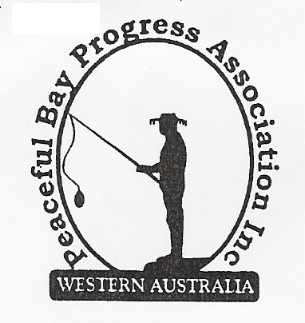

Meeting Opened: 9.05

Present: Hayden Jones (President), Katie Eddington (Treasurer), Mavis Jones (Secretary), Shannon Armstrong, Callum Baxter, Tony Armstrong, Reg Radford.

Apologies: Gill Irvine, Graeme Liddelow (Vice President), Janine Phillips.

1. Confirmation of Minutes from previous meeting 5 July, 2020

Moved: Katie Eddington 2nd Tony Armstrong – Accepted and carried by all.

2. Business Arising: All items covered in general business.

3. Correspondence:
IN:
10 July – cc’d in to email from Julie Benson toTerry Redman + pictures re Irwin Inlet .
14 July – email from Sue Mearns - agenda for Shire Ordinary meeting Tuesday 21 July on website
15 July – email from Microsoft advising subscription due soon. (forwarded to Katie)
21 July – email from Lindsey Heymans with attached letter from Martin Buczat responding to Julie
Benson re Irwin Inlet.
22 July – email from Katie re item from Sea Rescue for Newsletter.
24 July – email from Sue Mearns advising Minutes from Council meeting 21 July are on website.
27 July – email from David King advising opening of Irwin Inlet on Wednesday 29 July.
28 July – emails from July Savic organising labels for newsletter and addresses spreadsheet.
28 July – email from Gill with apology for August meeting and Hall door repairs.
– email from Paul Harris with his copy of a letter to Shire re Settlement Avenues.
– email from Janine re change to Newsletter.
– email from Ryan Harding SoD re Nornalup Jetty and boat ramp renewal project.
30 July– email from Callum approving the Newsletter.
– email from Katie approving the Newsletter.
– email from NRRA requesting letters of support for Nornalup jetty project.
– email from Claire Thompson - Agenda for special council meeting 4 August on website.
OUT:
7 July – email to Committee with minutes of July Meeting.
20 July – email to David King re Flag Hill lookout platform maintenance or replacement.

Moved: Shannon Armstrong 2nd Reg Radford - Accepted/Endorsed.

4. Finance Report:
All proceeding to budget. The annual Microsoft 365 subscription will be changed from
Callum’s name to Katie’s as Treasurer.
Shannon wants to ask the Shire of Denmark to put together a list of all money spent/allocated
to Peaceful Bay at the end of each year to be sent to the Progress and change name to PBPA
Expenditure Fund not “Reserve”. Hayden will follow up with SoD Finance. Reg said all this
information is made available on the Shire of Denmark Website for everyone to access and did
so on his phone and gave a verbal list of monies spent/allocated to Peaceful Bay and balance
of the Peaceful Bay Reserve Fund which had increased this year.

Moved: Katie Eddington 2nd Shannon Armstrong - Accepted/Endorsed.

5. Maintenance Report:
The spare sprinkler heads have been purchased for the oval retic. One needs replacing and
one spare.
The preferred fertiliser Turf Special for the oval and grassed areas is available at Elders.
Shannon advised the bushes on dual use pathway need trimming (Jeremy)

6. General Business:
July Newsletter – Ready to go out to membership. Callum will upload it to the Peaceful Bay
Website and email the existing list to advise that the Newsletter is on the website. The rest
will be mailed out on Tuesday. Also the Newsletter will be posted on Facebook Page.

Outdoor Furniture. The settings will need oil based paint for lasting protection and it was
agreed to purchase a 4 Litre tin. Hayden will source quotes for concrete bases with embedded
chains to secure the settings and make mowing easier. It was agreed that one be placed at
the basket ball court, one at the Oval near the BBQ and suggested one at the Community Hall,
one at garden area near Notice board and one on the grassed area near Sea Rescue building.
The bench seat will be located at the top of the sandy track beach access. A letter will be sent
to the Shire of Denmark to ask permission to locate the setting and bench on these two sites.

Nornalup Jetty and Boat Ramp Renewal Project. The Progress will forward a letter to Ryan
Harding, Shire of Denmark in support of the application for funding for this project.

7. Other Business:

PBPA Website – Reg will liaise with Callum to take on the updates and management of the
Peaceful Bay Progress Association website and posting electronic correspondence on Google
Drive.

Tony advised vehicles were using the Walkway between 4th and 5th Avenue and it needed
attention.

8. Meeting closed: 10.20 am Next Meeting: SUNDAY 6th September, 2020
(Mavis will be an apology for this meeting)

