PEACEFUL BAY PROGRESS ASSOCIATION INC  Peaceful Bay WA 6333  ABN: 54389092839 www.peacefulbayprogress.org.au  Committee Meeting Minutes  for Sunday 6 September, 2020  (Secretary’s version) | 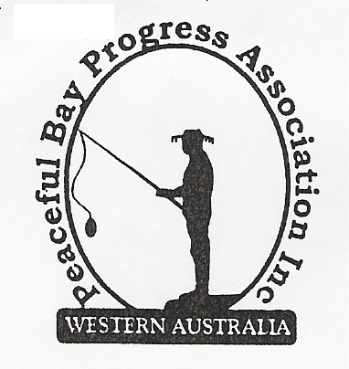

Meeting Opened: 9.05 am

Present: Hayden Jones (President), Graeme Liddelow (Vice President), Katie Eddington (Treasurer), Reg Radford, Gill Irvine, Shannon Armstrong, Tony Armstrong, Gill Irvine.

Apologies: Mavis Jones

1. Confirmation of Minutes from previous meeting 2nd August, 2020

Moved: Reg Radford 2nd Katie Eddington – Accepted and carried by all.

2. Business Arising: All items covered in general business.

3. Correspondence:
IN:
03 Aug – email from Emma Holliday, SoD Flyer re Bushfire Resilience meeting on 25 Aug.
05 Aug – email from Ryan Harding thanking the Progress for support of Nornalup Jetty.
06 Aug – email from SoD advising Special Council Meeting minutes 4 Aug are on Website.
12 Aug – email from Sod advising Agenda for Council meeting Tues 18 August is on Website.
14 Aug – email from Microsoft 365 Personal – subscription successfully charged.
18 Aug – email from Denmark CRC re Invitation Fundraising opportunity. (Cash for containers)
18 Aug – email with letter granting conditional approval to install outdoor furniture.
24 Aug – email from SoD advising Minutes of Council meeting 18 August are on Website.
28 Aug – email from Claire Thompson advising draft of procedure if Council decide to allow the
Peaceful Bay lease terms to be staggered. Final draft is aimed for October.
28 Aug – emails between Melanie Haymont and Hayden re water tank on oval and quarantining
water for fire emergency.
31 Aug – email re hall hire for Bibb Track afternoon tea. (forwarded to Katie)
31 Aug – email from Denmark CRC re updating Community Contact lists.
03 Sep – email from SoD re Containers for Change programme.

OUT:
02 Aug – emailed and posted out Mid-Year Newsletter to members
04 Aug – emailed Bushfire Resilience Flyer out to members on email list (Callum)
05 Aug – emailed letter to Ryan Harding SoD in support of Nornalup Jetty & Boat Ramp Renewal
05 Aug – emailed David King requesting permission to install outdoor furniture.
01 Sept – replied to Denmark CRC advising PBPA contact details are the same.

(Printed list of correspondence tabled at the meeting. Secretary to list as above)

Moved: Reg Radford 2nd Shannon Armstrong - Accepted/Endorsed.

4. Finance Report: All proceeding to budget.

A Credit Card to be raised on an account to facilitate payment for Microsoft 365 and other
payments requiring the treasurer to pay by card.

Moved: Katie Eddington 2nd Graeme Liddleow - Accepted/Endorsed.

5. Maintenance Report:
The Shire response table was discussed and it was agreed to write to David King and request
an update on items outstanding with August due dates.
Shannon will seek a quote for an extra layer of limestone blocks around the playground.

6. General Business:

Beautification project for this year.

Lopping’s Dump - Reg proposed we clear the green waste dump of all solid waste material at
our cost. All agreed.

“Containers for Change” project was discussed as a fundraiser for the Progress. Hayden
will follow up obtaining an ID number for the Progress and how we can manage collection and
return of containers to cash points in Denmark or if our local tip can assist.

Leasehold Reserve Fund - We need to decide on what percentage of the lease fee should
be put aside in the Peaceful Bay Reserve Fund and advise the Shire of Denmark.

7. Other Business:
It was suggested that as the Council Representative has not been able to attend many
meetings, we request an update from Cr Phillips on any issues before Council which concern
Peaceful Bay.

8. Meeting closed: 11.10 am Next Meeting: SUNDAY 4th October, 2020

