PEACEFUL BAY PROGRESS ASSOCIATION INC  Peaceful Bay WA 6333  ABN: 54389092839 www.peacefulbayprogress.org.au  Committee Meeting Minutes  for Sunday 4 October, 2020 | 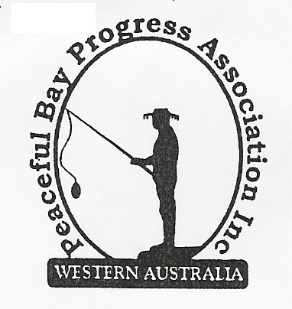

Meeting Opened: 9.00 am

Present: Graeme Liddelow (Vice President), Katie Eddington (Treasurer), Mavis Jones (Secretary), Tony Armstrong, Leanne Taylor, Gill Irvine, Reg Radford, Janine Phillips.

Apologies: Hayden Jones, Callum Baxter, Shannon Armstrong

1. Confirmation of Minutes from previous meeting 6 September, 2020

Moved: Katie Eddington 2nd Tony Armstrong – Accepted and carried by all.

2. Business Arising: All items covered in general business.

3. Correspondence:
IN:
09 Sept – email from SoD Council Meeting to be held on 15 Sept, 2020 on the Website.
09 Sept – email from Renee Wiggins SoD inviting subscription to monthly Newsletter.
17 Sept – email from NRRA re SoD Conversation Café to the held in Nornalup + Flyer.
18 Sept – email from NRRA re Picnic at Nornalup in January + Member update.
18 Sept – email from SoD advising Minutes from Council Meeting 15 Sept are on the Website.
21 Sept – email rom DWAG re weed control day on Friday 2 October at Peaceful Bay.
24 Sept – email from re Consultation Café on Tuesday 29 September at Peaceful Bay Hall.
29 Sept – email from Renee Wiggins with flyer on coming events in Denmark and inviting the
community to have a say.
OUT:
24 Sept – emailed letter to David King re items with an open status and August due date.
25 Sept – emailed Conversation Café invitation to members on email list, Thanks, Callum

Moved: Mavis Jones 2nd Gill Irvine - Accepted/Endorsed.

4. Finance Report:
All proceeding to budget. Katie has applied for grant and submitted costs for items listed.

Moved: Katie Eddington 2nd Leanne Taylor - Accepted/Endorsed.

5. Maintenance Report:
- Bench seat will be moved by Tony and Shannon and set up on site.
- Waiting on quotes for concrete bases for outdoor settings.
- Bees in Doctor’s Surgery. The bees have invaded the wall through a corner of the side
window. Katie will follow up and have them removed.
- The trees to the side of the Hall need lopping as they are close to power lines. Katie will follow up and arrange to have this done.

6. General Business:

Infrastructure Reserve Fund – It was decided to draft a letter to the Shire indicating our
preference of 25% of Lease Fees to be contributed to the fund with 5% annual increments.
The draft will be discussed at the next meeting 1st November before being submitted to
Council. The name of the fund also needs to be changed to be more specific as to what the
money is to be used for, otherwise it may be used for infrastructure unrelated to the leasehold.

Christmas Party – Saturday 19 December is when the Christmas Party will be held and
Friday 1 January 2121 will be the New Year Fun Day. Details to be finalised at future meeting.
It was suggested we write to the Shire of Denmark and ask for a $200 donation/contribution
towards the Christmas function and the New Year Fun Day as community fundraising
events

“Cash for Containers” Up and running with our ID posted on the Facebook page. The idea
of having a collection point at the Hall was discussed, however it was decided that it was not
worth the effort someone would have to put in. We agreed to collect cans from the Christmas
Party and New Year Fun Day as the collection would be easy to manage.

7. Other Business:
Reg raised the staggered leases. We have been advised the Council is aiming for October.
Janine to follow up on progress.

Loppings dump rubbish is to be cleaned up. Kim from Bow Bridge Earthmoving advised
Hayden he is on holidays and will attend to this on his return. Reg will follow up.

Reg & Gill asked that we write to the Shire of Denmark and request an instalment payment
plan for lease fees to be formalised and made a clear option on the Annual Lease Notice.

8. Meeting closed: 9.50 am Next Meeting: SUNDAY 1st November, 2020

