PEACEFUL BAY PROGRESS ASSOCIATION INC  Peaceful Bay WA 6333  ABN: 54389092839 www.peacefulbayprogress.org.au  Committee Meeting Minutes  for Sunday 6 December, 2020 | 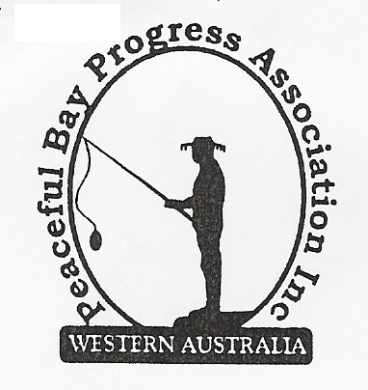

Meeting Opened: 9.05am

Present: Hayden Jones (President) Graeme Liddelow (Vice President) Katie Eddington (Treasurer) Mavis Jones (Secretary) Gill Irvine, Reg Radford
Guest: Peaceful Bay Bush Fire Brigade Captain Trevor Brown (10.00am)

Apologies: Callum Baxter

1. Confirmation of Minutes from previous meeting 8 November, 2020

Moved: Mavis Jones 2nd Gill Irvine – Accepted and carried by all.

2. Business Arising: All items covered in general business.

3. Correspondence:
IN:
2 Nov – letter from David Schober SoD re donation of $200 to community events costs.
11 Nov – email from Claire SoD Agenda for Council meeting Tuesday 17 November on website.
12 Nov – email from Reg with attached Invoice for Tree lopping at Hall.
13 Nov – email from DCRC Invitation Thank a Volunteer Day 5 December.
13 Nov – email from DCRC wanting a Santa for Christmas parade truck - 18 December
18 Nov – email from Hayden with quote from Great Southern Concreting – furniture bases.
18 Nov – email from Claire, SoD re Minutes of Special Meeting Tuesday 10 November on website.
23 Nov – email from Claire, SoD Minutes of Council meeting Tuesday 17 November on website.
24 Nov – email from DCRC concern over lack of responses to Thank A Volunteer Day.
24 Nov – email from Malcolm Murray advising payment of Subs.
25 Nov – email from Claire, SoD Agenda Special Meeting of Council Tuesday 1 Dec on website.
30 Nov – email from Renee Wiggins, SoD response to feral cats and rabbits policy letter.
3 Dec – email from Clair SoD Special Council Meeting Minutes Tuesday 1 December on Website.

OUT:
12 Nov – emailed letter to David Schober SoD re Infrastructure Reserve Fund.
12 Nov – emailed letter to David Schober SoD re Rabbits and Feral Cats at Peaceful Bay.
1 Dec – emailed letter with attached flyer to David Schober SoD – Invitation to Peaceful Bay
Progress Association events and thank you for $200 donation towards costs.
1 Dec – emailed Newsletter to Committee for approval.
1 Dec - email from Hayden to Great Southern Concreting advising go ahead with job.
4 Dec – emailed Newsletter to members on email list.

Moved: Hayden Jones 2nd Graeme Liddelow - Accepted/Endorsed.

4. Finance Report:
All proceeding to budget.
Moved: Katie Eddington 2nd Gill Irvine - Accepted/Endorsed.

5. Maintenance Report:

1. Bottom set of kitchen cupboards in the hall need upgrading – Hayden to follow up kit forms.
2. The concrete BBQs at the hall need to be removed as their condition is becoming close to
collapse. Keeping them as a heritage item is not feasible.
3. The bore requires constant monitoring and Hayden will work with Chris Darwin to locate the
problem.
4. Everything is in generally in good condition.
5. Dog access track to the beach needs attention. Write to Shire and request work.
6. Signage at Peaceful Bay Road/Ring Road junction needs rejuvenating also at Flag Hill
Lookout as signage is showing its age.

6. General Business:

Peaceful Bay Bush Fire Brigade – Captain Trevor Brown addressed the meeting and
reported on the activities of the Brigade which was of interest to those in attendance. At
present there are 30 members (25 active) and the Brigade is always willing to receive more
volunteers. Some planned burns have been cancelled by FESA for various reasons and will
most likely take place in or around March 2021. The lopping’s dump burns will also be under
the Brigades supervision and control.
Thank you to Trevor for taking the time to attend our meeting.

Christmas Party and New Year Fun Day – arrangements were made for these events.
Gill and Graeme will cook the BBQ for both events. Mavis will make coleslaw for Hamburgers
for Fun Day. Janine will supply lollies bagged up for both events and ice for Fun Day. Other
duties will be undertaken by whoever volunteers. The New Year Fun Day will start at the
earlier time of 11.00am. The availability of the Fire Truck for Father Christmas and rides at the
Christmas party is presently unknown, other arrangements may have to be made.

Response to rabbits and feral cats – A response from the Shire of Denmark was tabled.
The Shire has cat traps for hire and The Department of Agriculture and Food may assist with
rabbit control if required.

7. Other Business:
Reg raised the staggered leases issue. It was agreed to write to the Shire of Denmark and
request an update on progress and cc the Peaceful Bay Councillors in to the request.

8. Meeting closed: 10.35 am Next Meeting: AGM - SATURDAY 2ND 2021

