PEACEFUL BAY PROGRESS ASSOCIATION INC  Peaceful Bay WA 6333  ABN: 54389092839 www.peacefulbayprogress.org.au  Committee Meeting Minutes  for Sunday 7 February, 2021 | 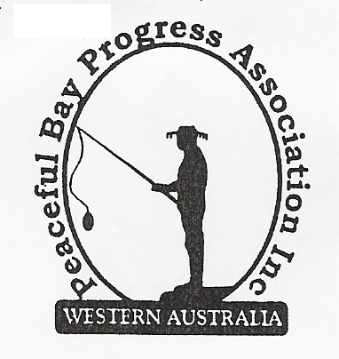

Meeting Opened: 9.10 am

Present: Hayden Jones (President), Mavis Jones (Secretary), Katie Eddington (Treasurer), Graeme Liddelow, Lorraine McNamara. Community member Lisa Jones.

Apologies:

1. Confirmation of Minutes from previous meeting 3 January, 2021

Moved: Graeme Liddelow 2nd Katie Eddington – Accepted and carried by all.

2. Business Arising: All items covered in general business.

3. Correspondence:
IN:
5 Jan – email from Cindy Smart re historical enquiry on cottage ownership.
9 Jan – email from RRRA re AGM agenda and supporting documents
11 Jan – email from Courtney Walsh, SoD community newsletter available
12 Jan – email from Charlotte McIntyre, GSDC re Invitation to NDIS Information Session.
17 Jan – email from Kim Smith with a quote for excavation work at Hall.
20 Jan – email from Claire Thompson SoD with invitation to meet the Australia Day Ambassador.

OUT:
5 Jan – email reply to Cindy Smart
8 Jan – emailed Thank you letter to Trevor Brown, Captain of PB Fire Brigade and his crew
8 Jan – emailed Thank you letter to Janine for donations to Fun Day and the Christmas Party.
4 Feb – emailed Committee contact details to Shire of Denmark.

Moved: Hayden Jones 2nd Katie Eddington - Accepted/Endorsed.

4. Finance Report:
All proceeding to budget. Katie advised the Broun family was willing to continue donating the
Hay Toss prize money for Fun Day. Final figures for Fun Day and Christmas Party will be
finalised when all accounts have been presented.

Moved: Katie Eddington 2nd Hayden Jones - Accepted/Endorsed.

5. Maintenance Report:
- Chris Darwin and Hayden have mapped solenoids on the oval reticulation and Hayden will
draw up maps and laminate for display for future maintenance reference.
- The Bore is now fixed and running well – Hayden removed an obstruction from the foot valve which was causing the problem. Oval is looking good.
- Kids are still climbing on the shade sails over the playground and causing damage. What do we do?
- The ‘jump track’ at the tank at the junction of East and First Ave is still closed. The area around the tank may now have to be stabilised.
- The lopping dump is going well since the rubbish has been cleared. Fingers crossed this will continue.
- Tap by the side door of the Hall needs attention as it is leaking badly. Hayden to follow up.
- The door closer on the Fly wire door is broken and needs replacing.

6. General Business:

Landscaping around the Hall. We received a quote from Kim Smith for excavation work and Steve Selby will be contacted regarding the retaining wall.

Concrete bases. The contractor is proving difficult to contact regarding the bases for the picnic settings. Hayden will again try for a response.

Kitchen - Replacement of the three old timber cupboards is an on going project.

PBPA Bins We have tried to locate where our bins are actually placed. Some are accounted for but the SoD may have recently tagged some of ours as theirs.

Dust Suppressant The dust suppression is going well and feedback so far from the Community is very positive. We will advise the Shire of feedback after Easter which will give enough time for the effect of the project to be assessed.

7. Other Business:

Cash for Containers. We made $109.60 from the first effort, however the lids need to be removed from bottles otherwise they are rejected. This is standard recycling practice and hopefully people will take the lids off for us, otherwise it will become too hard to continue.

8. Meeting closed: 9.45 Next Meeting: SUNDAY 7TH March, 2021

