PEACEFUL BAY PROGRESS ASSOCIATION INC  Peaceful Bay WA 6333  ABN: 54389092839 www.peacefulbayprogress.org.au  Committee Meeting Minutes  for Sunday 7 March, 2021 | 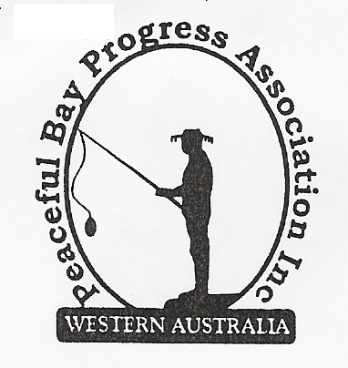

Meeting Opened: 9.00 am

Present: Hayden Jones (President), Reg Radford (Vice President), Katie Eddington (Treasurer), Mavis Jones (Secretary) Lorraine McNamara, Leanne Taylor, Graeme Liddelow, Tony Armstrong, Janine Phillips

Apologies: Nil

Acknowledgment of the passing of Rob (Tiger) Standish. Early member of Peaceful Bay community, did a lot in the early years in establishing the settlement and was a character well known around the Bay.

1. Confirmation of Minutes from previous meeting 7 February, 2021

Moved: Graeme Liddelow 2nd Tony Armstrong – Accepted and carried by all.

2. Business Arising: All items covered in general business.

3. Correspondence:
IN:
07 Feb – Card from Bow Bridge, Tingledale, Hazelvale Ladies thanking the Progress for the use of
the Hall for their fundraiser which raised $2000.00 for a classroom in Cambodia.
09 Feb – email from Claire Thompson SoD, Agenda for Council meeting is on the Website.
10 Feb – email from Claire Thompson requesting meeting to discuss Staggered Leases.
24 Feb – email from Claire Thompson confirming David Shober and herself can attend meeting on
Sunday 7 March at 4.30 at the Peaceful Bay Hall. Briefing notes attached.
25 Feb – email from Claire Thompson advising Council Meeting minutes 16 February on website.
04 Mar – email from Courtney Walsh SoD Tourism Strategy Community Workshops in March.
05 Mar – email from Claire Thompson requesting use of Hall on 6 April at 6 pm for Council
Locality meeting.

OUT:
12 Feb – minutes of 7 February PBPA meeting emailed to Committee Members.
23 Feb – emailed committee members requesting responses to meeting with SoD to discuss
Staggering Leases Process proposed for 4.30 Sunday 7th March at the Peaceful Bay
Hall.
25 Feb – emailed Briefing Note on Staggering Leases and confirmation of meeting to Committee
members.

Moved: Hayden Jones 2nd Graeme Liddelow - Accepted/Endorsed.

4. Finance Report:
All proceeding to budget.
Moved: Katie Eddington 2nd Hayden Jones - Accepted/Endorsed.

5. Maintenance Report:
Everything seems okay.
Stop Cock location. After the approach to the Council failed to produce any action to locate
and cap the stop cocks at the Hall and the RSL shed next door, it was decided to write to the
Council and formerly request the work be carried out so the Progress can engage a plumber to
fix minor problems.
The dust suppression on the village roads has received more positive feedback from the
community. It was agreed to write to the Shire of Denmark now instead of waiting until after
Easter, informing them of the positive feedback and request that this become an annual
budget item and the application be in the same time frame i.e. November

6. General Business:

Staggered Leases Process briefing note – The five options listed in the briefing were
discussed at length and a general consensus was reached by committee members to present
to David Shober and Claire Thompson at the meeting scheduled for 4.30 pm later today.

7. Other Business:
Reg asked where we are at with the landscaping and if we had any progress with the concrete
bases. Hayden advised we still have not heard from the concrete supplier but he has spoken
to Steve Selby regarding the retaining wall needed at the Hall.

Graeme advised he had suggested that the proposed Bike trail through Nornalup to the Valley
of the Giants be extended to Conspicuous through to Peaceful Bay. He will update us if there
is any development. He is also canvassing for Committee members but is not getting any
bites.

8. Meeting closed: 10.25 am Next Meeting: SUNDAY 4TH April, 2021
(Easter Sunday)

