PEACEFUL BAY PROGRESS ASSOCIATION INC  Peaceful Bay WA 6333  ABN: 54389092839 www.peacefulbayprogress.org.au  Committee Meeting Minutes  for Sunday 6 June, 2021 | 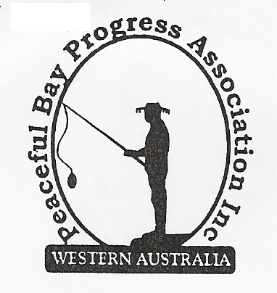

Meeting Opened: 9.05 am

Present: Hayden Jones (President), Katie Eddington (Treasurer), Mavis Jones (Secretary), Lorraine McNamara, Graeme Liddelow, Tony Armstrong

Apologies: Reg Radford (Vice President), Janine Phillips

1. Confirmation of Minutes from previous meeting 2 May, 2021

Moved: Hayden Jones 2nd Lorraine McNamara – Accepted/Endorsed.

2. Business Arising: All items covered in general business.

3. Correspondence:
IN:
03 May – Introductory email from Rosemarie Arnephie, SoD Community Development Officer.
03 May – email from Steph Marsh from Consumer Protection re Outreach service to Denmark.
07 May – email from Claire Thompson SoD Agenda for Council Meeting on 18 May on website.
13 May – email from Rosie Arnephie re Thank a Volunteer function 20 May.
18 May – email from KAB WA re Tidy Town competition.
24 May – email from Claire Thompson SoD re Minutes of Council Meeting on 18 May on website.
26 May – email from Janine re follow up to public toilet block maintenance and Synergy error.
28 May – email from Lisa Sanders for David King in response to confirmation of budget items
enquiry.
30 May – email from Hayden with sketch of hall landscaping for submission to SoD.
01 Jun – email from Hayden with Quote for Hall kitchen cupboards from Bunnings attached.
02 Jun – email from Martin Buczak re update on Peaceful Bay Road Work with attachment from
David King advising Inlet opening planned Thursday 3 June at 11.15.am.
03 Jun – email from Shannon Armstrong with correspondence between herself and David King
about the inlet opening for our information.
05 Jun – emailed letter from David Guthrie to NRRA re sprinkler system – Fire suppression
system at Hall and Fire Shed at Nornalup. For our information.
OUT:
18 May – emailed minutes of meeting 2 May to Committee members
26 May – emailed letter to David Schober (cc David King) re Budget Items confirmation.
30 May – emailed plan of hall landscaping to David Schober CEO for approval.

Moved: Graeme Liddelow 2nd Ka tie Eddington - Accepted/Endorsed.

4. Finance Report:
Report tabled and all proceeding to budget.

Moved: Katie Eddington 2nd - Accepted/Endorsed.

5. Maintenance Report:
1. Due to Denmark firm being unable to attend, Katie contacted Manjimup Glass to look into
windows repair/replacement at the Doctor’s surgery and the Hall. Katie will follow up.

2. A quote from Bunnings for $1477.00 was accepted and the old cupboards in the Hall will be
replaced. The tops will be an extra $300 approximately. Hayden will organise
transportation and Graeme offered to assist with installation.
6. General Business:

Landscaping at the Hall. William Bay Bobcats will be contacted with a view to purchase, transport and place the concrete blocks which will comprise the retaining wall. The rest of the landscaping can then proceed. Hayden to organise. The firm who quoted for the concrete pads for the picnic settings have not responded to communications. Hayden will try again to contact the firm.

Fifth Ave Entrance Garden. Katie commented that some plants were doing well but the garden bed needs replenishing. Suitable plants will be sourced to restore the balance.

7. Other Business:

Katie asked if a Subscription reminder could be placed on the Peaceful Bay Facebook page.

Hayden will also place the Peaceful Bay Road works update from the Shire of Denmark on the Facebook page. Hopefully, this will quell the rumours circulating around the Bay.

8. Meeting closed: 10.10 am Next Meeting: SUNDAY 4th July, 2021

