PEACEFUL BAY PROGRESS ASSOCIATION INC  Peaceful Bay WA 6333  ABN: 54389092839 www.peacefulbayprogress.org.au  Committee Meeting Minutes  for Sunday 4 July, 2021 | 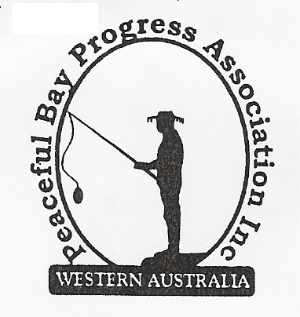

Meeting Opened: 9.00 am

Present: Hayden Jones (President), Reg Radford (Vice President), Mavis Jones (Secretary).
Graeme Liddelow.

Apologies: Katie Eddington, Janine Phillips, Lorraine McNamara, Tony Armstrong

1. Confirmation of Minutes from previous meeting 6 June, 2021

Moved: Graeme Liddelow 2nd Hayden Jones – Accepted and carried by all.

2. Business Arising: All items covered in general business.

3. Correspondence:
IN:
09 Jun – email from Claire Thompson advertising Public Health Plan Working Group vacancies.
15 Jun – email from Ryan Harding with approval of hall landscaping plan submitted.
16 Jun – email from Katie with attached letter from Dept of Transport re increase in cost of PBY
number plates.
17 Jun – email from Slyv Habal from Dept of Mines, Industry Regulation and Safety re forum in
Albany on consumer rights, scams, product safety and tenancy information on 21 June.
17 Jun – cc’d in to email from Paul Harris to the CEO at SoD re correspondence on roads.
23 Jun – email from Rosie Arnephie re Denmark 4youth Fest on 25-26 June with flyers attached.
23 Jun – email from Nicky Higgs re Community Grants open for applications.
30 Jun – email from Reg Radford re Peaceful Bay Lease Renewal.
01 Jul – email from Eva Overton SoD re Containers for Change Information Session.

OUT:
08 Jun – emailed minutes of meeting 6 June to Committee members
21 Jun – email to Shire of Denmark, cc David King re Paul Harris correspondence.
30 Jun – email reply to Reg re Lease renewal.

Moved: Mavis Jones 2nd Graeme Liddelow - Accepted/Endorsed.

4. Finance Report:
No report tabled due to Katie being away. Hayden advised quite a few subs payments have
come through in response to Facebook reminder.

5. Maintenance Report:
Graeme and Tony have sprayed a coat of protective gloss paint on the picnic settings.
It seems Peaceful Bay came through the storm last week relatively unscathed.

6. General Business:

Lease renewal update. (It is proposed that if Council agree in principle to allowing the leases
to be renewed under certain circumstances, that this intention be advertised locally for public
comment. In addition, it is proposed that Council’s intention be communicated to all current
leaseholders and the Peaceful Bay Progress Association, inviting them to provide any
comments.

The Denmark Shire Council policy allows new 21 year leases under the following
circumstances
A. Assignment of lease (sale)
B. Assignment of lease – on bequeathment: or
C. Upon completion of substantial development of the premises (valued over $50,000).
(Taken from minutes of Ordinary Meeting of Council – 15 June, 2021)

Increase in PBY Number plates. The Dept of Transport has raised the cost of number
plates. The decision on whether to increase our costs will be made at the next meeting in
August.

Hall kitchen cupboards. The kitchen cupboards have been purchased and Hayden has
transported them to the Hall. Graeme and Reg will begin unpacking and assembling them
during the week as time allows.

Hall landscaping update. Approval was granted by the Shire of Denmark and Hayden met with Ben from William Bay Bobcats on site to discuss scope of work. The concrete blocks will be sourced and transported to the Bay. Hayden to follow up.

7. Other Business: Shire of Denmark - Community Grants Application. It was suggested
we apply for a grant to fund a project i.e.: provide playground equipment such as a climbing
frame, etc. It will be on the Agenda for the August meeting, so please bring your ideas for a
suitable project to the table.

8. Meeting closed: 9.45 am Next Meeting: SUNDAY 1st August, 2021.

