PEACEFUL BAY PROGRESS ASSOCIATION INC  Peaceful Bay WA 6333  ABN: 54389092839 www.peacefulbayprogress.org.au  Committee Meeting Minutes  for Sunday 1 August, 2021 | 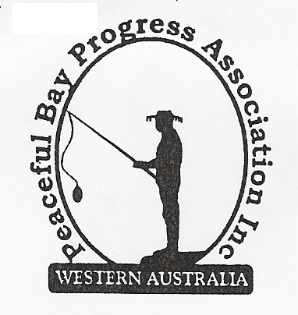

Meeting Opened: 9.05 am

Present: Hayden Jones (President), Reg Radford (Vice President), Katie Eddington (Treasurer), Mavis Jones (Secretary), Graeme Liddelow, Lorraine McNamara, Tony Armstrong

Apologies:

1. Confirmation of Minutes from previous meeting 4 July, 2021

Moved: Graeme Liddelow 2nd Hayden Jones – Accepted and carried by all.

2. Business Arising: All items covered in general business.

3. Correspondence:
IN:
15 July - email from Microsoft advising payment schedule for Microsoft 365 Personal subscription
will be taken out on 14 August, 2021.
19 July – email from Janine with attached Public Comment on Peaceful Bay Leases
advertisement.
19 July – email from Janine with attached copy of the letter posted to all leaseholders.
25 July – email from Ray and Jo Walker copy of their submission re Staggered leases.
30 July – email with Invoice attached from The William Bay Bobcat – Hall landscaping.

OUT:
04 July – emailed Meeting Minutes to committee members.
06 July – emailed Claire Thompsons confirmation that each leaseholder will receive a letter
regarding Staggered Leases Policy invitation to comment.
24 July – email list provided with copy of letter regarding Staggered leases and encouraged to
respond.

Moved: Mavis Jones 2nd Tony Armstrong - Accepted/Endorsed.

4. Finance Report:
All proceeding to budget. Report tabled for 2 months. Number Plates are still being
purchased.
Moved: Katie Eddington 2nd Hayden Jones - Accepted/Endorsed.

5. Maintenance Report:
Fire Water Tank at junction of East and First Ave needs maintenance due to bike jumps
eroding the earth base. Ryan Harding from the Shire of Denmark advised this will be
undertaken and measures put it place to stop unauthorised tracks being made around the
base of the tank.
New tables for use at Hall for outside events as the old ones are becoming unusable. Hayden
will follow up on replacements and report back.

6. General Business:

Lease - The staggered lease proposal has gone out to Leaseholders and the general public
for comment. Community members have been contacted through email and encouraged to
respond in writing by the due date. This item has also been placed on Facebook with a
request to support the proposal. The PBPA will submit a written response to the Shire
supporting the new 21 year lease policy for the leasehold.
PBY Number plates – It was agreed not to increase the price of the number plates at this
time. This can be revisited at the AGM.

Hall kitchen cupboards progressing well. Hayden to source new sink, taps and splashback for sink cupboard and kick boards for all cupboards.

Hall landscaping update. The retaining wall blocks are now in place, the ground levelled and
the BBQs removed. Hayden will contact Denmark Concreting and discuss concrete pads for
the Outdoor Furniture and a continuation of the concrete section at the side door to pick up the
shed doorway and adjoin the retaining wall.

Community Grants - The application process was deemed to be very involved and we did not
have enough time to decide on a project and put in the application. It was agreed to leave it
for this year.

7. Other Business:

Hayden reported that the Containers for Change project is going well and has raised $300 for the Progress so far.

Katie advised that the Bibbi Track group have applied to use the Hall for their annual morning tea. Also a request has been made to use the Hall for an Art Exhibition by a community member. The committee agreed on the hire fee of $100 for this event.

Katie also requested that we write to the Shire of Denmark to raise concerns of the Peaceful Bay Community over the 6 hour battery time available in the event of power outages which effects landline and mobile phone communication. It is inadequate in an emergency situation.

Lorraine advised that the vacuum cleaner needed replacing. Katie will purchase a replacement.

Tony said that a load of gravel was needed to fill in a huge pothole outside the Fire Shed. The Fire Brigade could request this from the Shire.

Reg suggested we write and remind the Shire about the dust suppressant program at a later date.

8. Meeting closed: 10.15 am Next Meeting: SUNDAY 5th September, 2021
Mavis Jones (Secretary) and Graeme Liddelow will be
an apology for this meeting.

