PEACEFUL BAY PROGRESS ASSOCIATION INC  Peaceful Bay WA 6333  ABN: 54389092839 www.peacefulbayprogress.org.au  Committee Meeting Minutes  for Sunday 5th September, 2021 | 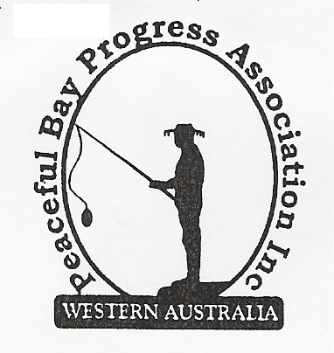

Meeting Opened: 9.05 am

Present: Hayden Jones (President), Katie Eddington (Treasurer), Lorraine McNamara,
Tony Armstrong.

Apologies: Mavis Jones, Graeme Liddelow, Reg Radford, Janine Phillips

1. Confirmation of Minutes from previous meeting 1st August, 2021:
Moved: Lorraine McNamara 2nd Tony Armstrong – Accepted and carried by all.

2. Business Arising: All items covered in general business.

3. Correspondence
IN:
03 Aug – email from Courtney Walsh SoD, acknowledgement of receipt of letter for Telstra Forum.
06 Aug – email from Ryan Harding re Contract Cleaner for Peaceful Bay Toilets.
10 Aug – email from Claire Thompson re Minutes of special meeting 3 August on website.
12 Aug - email from Claire Thompson re Western Locality Meeting on Tuesday 7 September at
Tingledale Hall.
15 Aug – email from Microsoft 365 Personal advising our Subscription was charged on Saturday
14 August.
20 Aug – email from Rosie Arnephie re invitation to launch of Denmark Community Directory.
23 Aug – email from Claire Thompson re nominations for 2021 Local Elections in October.
26 Aug – email from Candidate information session at Shire Offices on Wednesday 1 September.
01 Sep – email from Rosie Arnephie re offer of Wheelchair to PBPA ex Denmark Surf Club.

OUT:
03 Aug – Letter to David Schober re PBPA comments for Community Forum with Telstra.
11 Aug – Letter to David Schober with comments on Shire of Denmark’s Proposed Staggered
Lease Policy.
Moved: Hayden Jones 2nd Katie Eddington - Accepted/Endorsed.

4. Finance Report:
All proceeding to budget.

Moved: Katie Eddington 2nd Hayden Jones - Accepted/Endorsed.

5. Maintenance Report:
Kitchen update – Nothing further has been done to install the new cupboards.

6. General Business:
Concrete pad saga is still ongoing due to the ground being too wet to proceed.
Outdoor tables will be purchased when stocks are available.
Wheelchair Offer -It was agreed that the Wheelchair offered to the PBPA from the Shire of
Denmark would not be used and the Shire would be informed on this decision with thanks.

7. Other Business

8. Meeting closed: 9.55 am Next Meeting: Sunday 3rd October, 2021

