PEACEFUL BAY PROGRESS ASSOCIATION INC  Peaceful Bay WA 6333  ABN: 54389092839 www.peacefulbayprogress.org.au  Committee Meeting Minutes  for Sunday 3 October, 2021 | 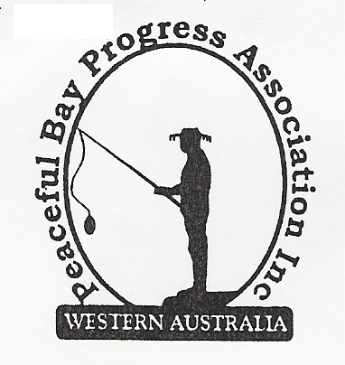

Meeting Opened: 9.03 am

Present: Hayden Jones (President), Reg Radford (Vice President), Katie Eddington (Treasurer), Mavis Jones (Secretary), Graeme Liddelow, Lorraine McNamara, Tony Armstrong.

Apologies: Janine Phillips

1. Confirmation of Minutes from previous meeting 5 September, 2021

Moved: Katie Eddington 2nd Graeme Liddelow – Accepted and carried by all.

2. Business Arising: All items covered in general business.

3. Correspondence:
IN: - Nil

OUT:
17 Sep – email to Rosie Arnephie declining offer of Wheelchair.
30 Sep – emailed Minutes to Committee members.

Moved: Mavis Jones 2nd Tony Armstrong - Accepted/Endorsed.

4. Finance Report:
All proceeding to budget.

Moved: Katie Eddington 2nd Hayden Jones - Accepted/Endorsed.

5. Maintenance Report:
East Avenue pot holes particularly bad – may need to look at bitumen in the future.
Also West Avenue is in similar state with pot holes.
The bollards separating the boat launch area and the swimming beach have been washed
away and vehicles are being driven through. It has been reported to the Shire but no action to
replace the bollards as yet.

6. General Business:
- Hall kitchen cupboards – organise time for installation in the coming weeks. (Graeme, Tony, Hayden, Reg)
- Date for Christmas Party was agreed as Saturday 18 December and New Year Fun Day Saturday 1 January 2022.
- Newsletter – Due to go out November. Requested Fire Brigade news item (Tony and Graeme to follow up). Katie advised Sea Rescue Group will be same as usual.
- Water tank at 1st & East Ave - After Hayden put in a Works Order, Ryan Harding from the Shire of Denmark has asked the PBPA to facilitate the erection of a barricade to stop kids on bikes making a jump around the water tank as this activity is compromising the stability of the base. Hayden will follow up with Jeremy.
- Loppings Dump - Tony advised that Greg’s tractor is in need of major repairs. The Progress may need to look at other options if the cost of repairs is too high.
- Rubbish Bins – The post holding the bin at the Hall has rusted away and been removed by the Shire. Hayden has requested the Shire provide 4 bins to be under the PBPA control to be placed in areas as required over the peak periods.
- Folding tables – The Committee authorised Hayden to purchase 4 folding tables for use outside at the Christmas Party and the Fun Day.
- Concrete Pads – This is ongoing and will proceed when the Oval is dry enough to access.
- Bike Rack - It was decided to relocate the bike rack at the Gazebo area across the road to the beginning of the sandy track beach access area, as most kids drop their bikes there. It will hopefully mean safer public access.

7. Other Business:
- Reg – enquired about the staggered lease progress. We will contact the Shire and ask for an update on the process. Also Reg suggested we ask when the Dust Suppression Programme will take place – write to Shire and request confirmation. Further it was agreed to write to the Shire and ask when the Village gravel roads are to going to be repaired/contoured and graded as they are in a bad state after the winter rains.
- Graeme – He and Tony will disassemble the old hall cupboards. He will also contact the Fire Brigade regarding a Newsletter item.
Also he observed that the revamped basketball half court is still being used
extensively by the community.
- Tony – will follow up to obtain a quote for cost of tractor repairs to be considered at next meeting.
- Hayden – Suggested that we obtain (6) galvanised goal posts – 2 concreted at the Hay Toss end of the oval and 4 removable at the other end as the temporary plastic goal posts have proved very popular with the young footy players. The Committee approved that Hayden purchase the galvanised posts to amount of approximately $300.

8. Meeting closed: 10.00am Next Meeting: SUNDAY 7th November, 2021
Graeme is an apology for this meeting

