PEACEFUL BAY PROGRESS ASSOCIATION INC  Peaceful Bay WA 6333  ABN: 54389092839 www.peacefulbayprogress.org.au  Committee Meeting Minutes  for Sunday 7 November, 2021 | 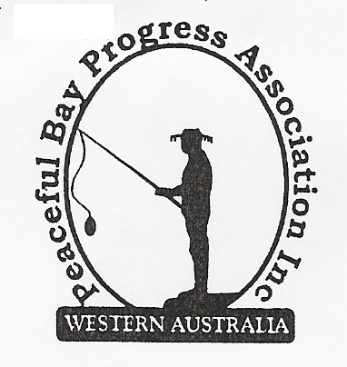

Meeting Opened: 9.03 am

Present: Hayden Jones (President), Reg Radford (Vice President), Katie Eddington (Treasurer), Mavis Jones (Secretary), Lorraine McNamara, Leanne Taylor, Janine Phillips

Apologies: Graeme Liddelow, Tony Armstrong

1. Confirmation of Minutes from previous meeting 3 October, 2021

Moved: Hayden Jones 2nd Reg Radford – Accepted and carried by all.

2. Business Arising: All items covered in general business.

3. Correspondence:
IN:
12 Oct – email from Graeme Liddelow re loppings dump tractor repairs.
15 Oct – email from Parks & Wildlife Service re management plans Walpole Wilderness.
25 Oct – email from Rosie Arnephie SoD re Community Citizen of the Year Awards.
25 Oct – email from Claire Thompson SoD – Council meeting minutes 19 October on website.
26 Oct – email from Janine Phillips re staggered lease update requested by Reg.
29 Oct – email from Eva Overton SoD re Containers for Change register.
31 Oct – email from Ray Walker re hall booking.
04 Nov – email from Claire Thompson with response to staggered lease policy update.
05 Nov – email from Great Southern Concrete with Invoice attached (Katie)

OUT:
03 Oct – emailed Minutes to Committee members.
06 Oct – emailed letter to David Shober, CEO re confirmation of Dust Suppression programme.
06 Oct – emailed letter to David Shober, CEO re Staggered Lease Policy update.
06 Oct – emailed letter to David King, SoD re Village gravel road maintenance
31 Oct – emailed Janine’s lease update requested by Reg to committee members.
31 Oct – emailed SoD requesting response to correspondence sent to David Shober & David King
on 6 October.

Moved: Mavis Jones 2nd Lorraine McNamara - Accepted/Endorsed.

4. Finance Report:
All proceeding to budget.

Moved: Katie Eddington 2nd Hayden Jones - Accepted/Endorsed.

5. Maintenance Report:

Beach Access Steps – some of the sand at the bottom has eroded away. Hopefully the tides
will replace the sand before the holidays, otherwise it will need attention.
Village roads – ongoing issue. Shire has supply of dust suppressant ready to lay once the gravel roads are ready.
Drains need clearing before next rains to reduce the risk of flooding.
Oval Reticulation and bore – Hayden has checked all running okay and bore operating well.
Picnic tables – have eye bolts and chains ready to go. Purchase more gloss paint for one last coat.
Water Tank on East Ave – Shire will provide copper logs for barrier fence around the tank to prevent kids riding their bikes around the base.
Plants for garden at 5th Avenue junction. Janine to follow up and source suitable plants.

6. General Business:
- Hall kitchen cupboards installation progressing well. The sink unit will be left until after New Year.
- Arrangements for Christmas Party & New Year Fun Day. Probably will be the same as last year, although we need more volunteers to assist with the Fun Day. Leanne offered to source the bread rolls and onions for both events. Final arrangements to be made at the next meeting in December
- Newsletter – A few alterations needed.
- Staggered Lease Policy update – Claire Thompson advised the lease was with Council solicitors and is most likely to go Council in February, 2022, as it is unlikely to be ready for the December meeting of Council.

7. Other Business:
Speed humps were suggested for 1st Ave to try to slow vehicles down any maybe divert traffic
to the Ring Rd. Hayden to follow up.
Reg suggested a “smilie face” machine (congratulates drivers if they are below the speed limit)
for East Ave to encourage drivers to slow down and a table for East Ave/1st Ave junction.
Reg also entered an apology for the December meeting.
Janine suggested we invite the Councillor for Nornalup, Jackie Ormsby to the Bay to
familiarise herself with Peaceful Bay and issues and concerns the area is facing.

8. Meeting closed: 10.30am Next Meeting: SUNDAY 5th December, 2021
(Reg is an apology)

