PEACEFUL BAY PROGRESS ASSOCIATION INC  Peaceful Bay WA 6333  ABN: 54389092839 www.peacefulbayprogress.org.au  Committee Meeting Minutes  for Sunday 9 January, 2022 | 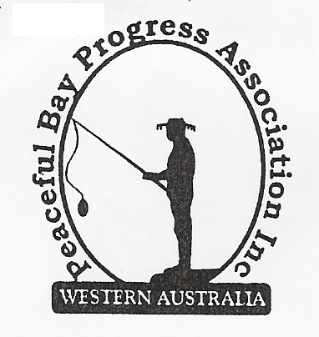

Meeting Opened:

Present: Hayden Jones (President), Reg Radford (Vice President), Katie Eddington (Treasurer),
Mavis Jones (Secretary), Chris Toovey, Kimmie McCarthy, Keli Allison, Margaret Broun,
Lorraine McNamara, Gill Irvine.

Apologies: Tony Armstrong, Leanne Taylor, Graeme Liddelow

1. Confirmation of Minutes from previous meeting 5 December, 2021

Moved: Katie Eddington 2nd Reg Radford – Accepted/Endorsed.

2. Business Arising: All items covered in general business.

3. Correspondence:
IN:
07 Dec – email from Jackie Ormsby in response to invitation – sorry she did not look at the email.
15 Dec – email from David King requesting resending of correspondence from 6 October.
24 Dec – email from Lisa Sanders from CEO David Schober in response to request for $200
donation towards Xmas Party and Fun Day.
24 Dec – email from Claire Thompson advising Council Minutes 21 December are on the website.

OUT:
08 Dec – email response to Jackie advising the date of AGM and will forward meeting dates 2022.
21 Dec – emailed David King the correspondence sent on 6 October as requested.
26 Dec – emailed 5 December meeting minutes out to Committee members.

Moved: Hayden Jones 2nd Reg Radford - Accepted/Endorsed.

4. Finance Report:
All proceeding to budget. The annual funding has been received from the Shire of Denmark.

Moved: Katie Eddington 2nd Margaret Broun - Accepted/Endorsed.

5. Maintenance Report: The Oval, the Hall area and the Bay in general is looking neat and tidy.

6. General Business:
- Dates for 2022 Committee Meetings. All meetings are on a Sunday at 9.00am.
February 6 March 6 April 3 May 1
June 5 July 3 August 7 September 11
October 2 November 6 December 4 AGM -TBA
Welcome to the new committee members, Keli, Kimmie, Chris, Margaret and Gill

- Village gravel roads. We are waiting for a response from David King to our latest letter when he returns to work and agreed to write to remind him. Kimmie offered to use her contact to source quality of gravel available and report back to the committee.

- Items from the floor
- Fill is needed in an area near the lopping’s dump. Reg to follow up and organise with Kim
- We agreed to write to the SoD and request the Rubbish bin on the oval be attached and
locked to a pole to prevent vandals dragging and using the bin as a ‘step up’ to getting on
top of the shade sails over the playground.
-The need for a toilet at the Sea Rescue car park is becoming an issue. Write to the SoD to inquire about the possibility of providing Chemical/waterless toilets similar to those provided in National Parks and remote tourist spots.

7. Other Business:

New Committee Members introduced themselves.

Gill expressed concern at the need for people to park vehicles along the launch area with
gazebos and picnics, etc. After discussion we agreed that as long as they don’t impinge on
the boat launching stretch near the jetty there is not a lot we can do.

8. Meeting closed: 9.00am Next Meeting: 6th FEBRUARY, 2022

