PEACEFUL BAY PROGRESS ASSOCIATION INC  Peaceful Bay WA 6333  ABN: 54389092839 www.peacefulbayprogress.org.au  Committee Meeting Minutes  for Sunday 3 April, 2022 | 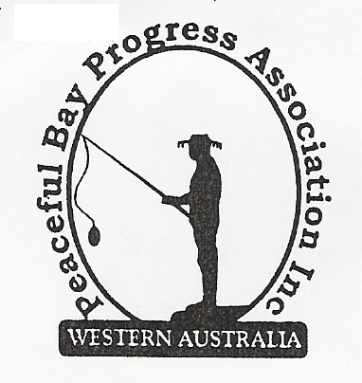

Meeting Opened: 9.05 am

Present: Hayden Jones (President), Katie Eddington (Treasurer), Mavis Jones (Secretary), Lorraine McNamara, Graeme Liddelow, Margaret Broun and Cr Janine Phillips, Council Representative.

Apologies: Kimiora McCarthy, Keli Elliott, Chris Toovey, Leanne Taylor, Gill Irvine

1. Confirmation of Minutes from previous meeting 6 March, 2022

Moved: Graeme Liddelow 2nd Hayden Jones – Accepted/Endorsed.

2. Business Arising: All items covered in general business.

3. Correspondence:

IN:
02 Mar – email from Reg re firebreak work
04 Mar – email from David King re Various matters - correspondence received from PBPA
18 Mar – email from Callum re Domain name renewal
21 Mar – email from Claire Thompson – Locality meeting at Peaceful Bay
22 Mar – email from Claire Thompson – Notice of Intention Dispose of Land
24 Mar – email from Claire Thompson Minutes from Council meeting on 15 March on website.
25 Mar – email from Lisa Sanders re Public Toilet Block at swimming beach access.

OUT:
09 Mar – Reply to Molly Smith re ease of beach access for seniors.
10 Mar – Letter to CEO at SoD re Signage damage on sandy track beach access.
20 Mar – Reply to Callum re Domain name renewal.

Moved: Katie Eddington 2nd Lorraine McNamara - Accepted/Endorsed.

4. Finance Report:
All proceeding to budget. Jenny Broun has donated $100 for the Hay Toss prizes on Fun Day on behalf of the De Landergraff family. A letter of thanks will be sent to Jenny.
Katie suggested we fund the replacement and upgrading of the wooden signage around the Bay using the annual grant from the Shire of Denmark.

Moved: Katie Eddington 2nd Hayden Jones - Accepted/Endorsed.

5. Maintenance Report:
- The walkway between Fourth Av at the East Ave end and Fifth Ave has an obstruction put in place to stop motorist driving through.
- The Shire Council will clear drains in the Freehold and Leasehold areas. Graeme to follow up.
- It was agreed to write to the Shire of Denmark and request the following
- The carpark at the Gazebo area be raised up and sealed.
- The rubbish tip access crossover be bituminised.
- An update on the platform and steps work.
- That the Shire investigate through Main Roads the feasibility of a slipway from South Coast Highway accessing Peaceful Bay Road.

6. General Business:
- PBPA Domain name, email addresses and website. Renewal was discussed then it was agreed to renew the Website and email addresses, plus Domain name for a further term. Callum will be advised of our decision and Katie will contact him re transferring payment responsibility directly to the Progress.

- Report re sealing of village roads. The email from Kimiora was clarified, Grant (contractor) indicated it would be an expensive project.

- Shire of Denmark Budget Items. It was agreed to submit a list of projects for Peaceful Bay to be consideration in the next Shire budget –

- A Toilet block to be built adjacent to the boat trailer and car park at the Sea Rescue building.
- Beach access inclusivity for disabled, seniors and others.
- A fitness park for the community to be sited on the Oval.

It was also suggested we ask for input from the community on projects they may
want through our Facebook page and Friends of Peaceful Bay page.

ACKNOWLEGEMENTS: Sadly, we acknowledge the passing of three of our community members – Daphne Reeves, Leila Adams and Syd Matthews. The Bay was enriched by their presence and contributions over the years and we extend our condolences to the respective families.

7. Other Business:
Graeme advised that he was unable to progress with the hall kitchen project. He will flag the
drain clearing with the Shire and look at mechanical fire protection around the community.

Margaret Broun and Graeme Liddelow will be an apology for the 2 May Meeting

8. Meeting closed: 10.30 am Next Meeting: 2nd MAY, 2022

