PEACEFUL BAY PROGRESS ASSOCIATION INC  Peaceful Bay WA 6333  ABN: 54389092839 www.peacefulbayprogress.org.au  Committee Meeting Minutes  for Sunday 1 May, 2022 | 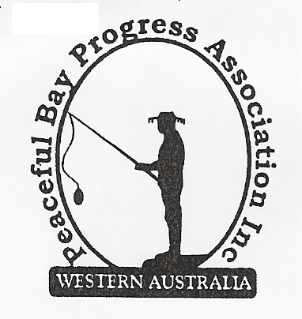

Meeting Opened: 9.00 am

Present: Hayden Jones (President), Reg Radford (Vice President) – on speaker phone,
Katie Eddington (Treasurer), Mavis Jones (Secretary), Chris Toovey, Lorraine McNamara,
Leanne Taylor.

Apologies: Margaret Broun, Graeme Liddelow, Kimiora McCarthy, Janine Phillips (Council Rep)

1. Confirmation of Minutes from previous meeting 3 April March, 2022

Moved: Lorraine McNamara 2nd Katie Eddington – Accepted and carried by all.

2. Business Arising: All items covered in general business.

3. Correspondence:
IN:
03 Apr – email from Chris Briggs Wedge Island Progress Association committee member
requesting information on our leases with the Shire of Denmark. (Hayden rang and
spoke to Chris).
10 Apr – Automatic reply from SoD re correspondence received.
20 Apr – email from Callum advising of transfer of Domain name, email and website to PBPA
28 Apr – email from Claire Thompson re staggered lease update.
28 Apr – email from David Schober re correspondence (which he had just read)

OUT:
03 Apr – emailed Callum to advise of our decision to renew the Domain name, Website and email.
10 Apr – emailed Thank You letter to Jenny Broun for prize money for Hay Toss at Fun Day.
10 Apr – emailed letter to Shire of Denmark listing budget items for consideration – Toilet block at
Sea Rescue carpark. – Beach Access – Fitness stations.
10 Apr – emailed letter to SoD re provision of slipway from South Coast Highway to Peaceful Bay
Road.
10 Apr – emailed letter to SoD re Maintenance items at Peaceful Bay – Swimming beach access
steps and platform – Tip Access crossover – Gazebo area carpark.
11 Apr – emailed letter to SoD re Peaceful Bay leasehold staggered lease update.
22 Apr – emailed SoD to advise our email was not operating.
30 Apr – emailed SoD to advise our email was now operational as before.

Moved: Hayden Jones 2nd Chris Toovey - Accepted/Endorsed.

4. Finance Report:
All proceeding to budget. Containers for Cash income very steady.

Moved: Katie Eddington 2nd Hayden Jones - Accepted/Endorsed.

5. Maintenance Report:
- Jeremy has placed and replaced a removable bollard on the walkway at the end of East Ave between Fourth and Fifth Ave to prevent vehicles using this as a shortcut to Fifth Ave and beyond.
- Kerbing may be considered as mowing is becoming difficult around the boat trailer carpark because grass is growing into the bitumen.
- Reg will progress signage replacement around the Bay with Larry James.
6. General Business:

- In response to an approach from a community member regarding large salmon heads being left on the beach It was agreed to write to the Shire of Denmark and to enquire about the possibility of a sign advising that there is a bin where fish offal can be disposed of at the Peaceful Bay Tip.
- A suggestion was put forward in an effort to alleviate the toilet issue at the Sea Rescue carpark and surrounds, that a sign be erected advising that public toilets are located at the swimming beach access carpark. We will write to the Shire of Denmark and request signage.

The committee agreed that at this point of entry, there was no visible information about these facility locations for first time visitors at the Bay.

Hayden tabled a list of responses to the Facebook post inviting input about things the community would like for the Bay. The response was pleasing, and most of them we already have submitted to the Shire of Denmark for budget consideration.

7. Other Business:

Reg met with Kim Smith and walked the area needing work and it will probably be done in June/July.
Christine Toovey is now an Administrator of the Facebook page assisting Kristy Bailey.
Lorraine advised items of gym equipment have been donated. Katie and Lorraine will organise storage until it can be decided where it will eventually be placed. It was also suggested that a Sub Committee be formed to investigate options for “Fitness Stations” around the Bay such as funding, types of equipment and locations.
Hayden said he would like to see an aggressive speed hump installed at the junction of First Ave and the Ring Road as vehicles were still travelling too fast.

8. Meeting closed: 9.55 am Next Meeting: 5th JUNE, 2022
Margaret Broun, Katie Eddington and Mavis Jones will be apologies for the June Meeting.

