PEACEFUL BAY PROGRESS ASSOCIATION INC  Peaceful Bay WA 6333  ABN: 54389092839 www.peacefulbayprogress.org.au  Committee Meeting Minutes  for Sunday 5 June, 2022 | 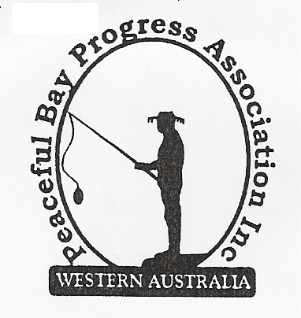

Meeting Opened:

Present:

Apologies: Margaret Broun, Katie Eddington, Mavis Jones

1. Confirmation of Minutes from previous meeting 1 May, 2022
Moved: 2nd – Accepted and carried by all.

2. Business Arising: All items covered in general business.

3. Correspondence:
IN:
03 May – email from Tony Armstrong advising new email address and returning in July.
03 May – email from Margaret Broun re working party for gym equipment and storage of same.
04 May – email from David Schober CEO – replay to maintenance and Budget items.
05 May – email from Lisa Sanders advising secure bin post is currently in hand and shade sails
should have already been removed for winter and repairs carried out.
06 May – email from Claire Thompson re Agenda for Council meeting is on website.
06 May – email letter from David Schober advising signage request will be progressed.
09 May – email from Ryan Harding re planned power outage on First Avenue 20th May.
23 May – email from Claire Thompson re Minutes of Council meeting Tuesday 17 May on website.
24 May – email from Kathleen Whitfield with requested signage proposal for our comment.

OUT:
02 May – emailed letter to Davis Schober re Fish Offal disposal and Toilet location signage.
02 May – email to David King requesting follow up on secure bin post, which was approved and
was supposed to have been done in January.
24 May – reply to Kathleen Whitfield re signage proposal advising the June meeting of PBPA will
review.
24 May – emailed meeting minutes to Tony Armstrong as requested.
24 May – emailed reply to Margaret thanking her for putting her hand up for working party.

Moved: 2nd - Accepted/Endorsed.

4. Finance Report:

Katie (Treasurer) is away and is an apology for this meeting. Finance report not available this
month.

5. Maintenance Report:

6. General Business:
- Signage Proposal.
- Items from the floor.

7. Other Business:

8. Meeting closed: Next Meeting: 3rd JULY, 2022

