PEACEFUL BAY PROGRESS ASSOCIATION INC  Peaceful Bay WA 6333  ABN: 54389092839 www.peacefulbayprogress.org.au  Committee Meeting Minutes  for Sunday 7 August, 2022 | 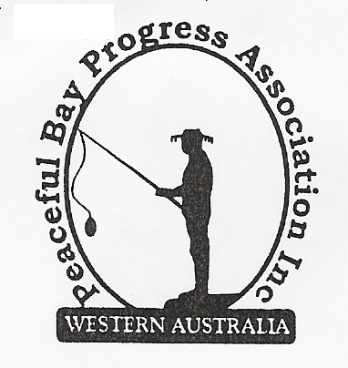

Meeting Opened: 9.05am

Present: Hayden Jones (President), Katie Eddington (Treasurer), Mavis Jones, (Secretary), Graeme Liddelow, Margaret Broun, Leanne Taylor, Lorraine McNamara, Tony Armstrong, Kimiora McCarthy. Community member - Neil Taylor

Apologies: Christine Toovey, Gill Irvine

1. Confirmation of Minutes from previous meeting 3 July, 2022

Moved: Margaret Broun 2nd Katie Eddington – Accepted and carried by all.

2. Business Arising: All items covered in general business.

3. Correspondence:

IN:
Jul 07 – email from Kathleen Whitfield SoD re signage email – will review it.
Jul 08 – email from Claire Thompson with lease update.
Jul 08 – email from Claire Thompson Agenda for Council Meeting on 19 July on website.
Jul 10 – email from Cr Jackie Ormsby spoke with CEO re issues raised at our meeting.
Jul 12 – email from Kathleen Whitfield requesting signage position on diagrams.
Jul 15 – email from Microsoft advising Renewal of 365 scheduled for August 14 2022.
Jul 28 – email from Claire Thompson with Draft Lease and Policy attachments.
Jul 28 – email from Claire Thompson Council Meeting Minutes 19 July on Website.
Aug 4 – email from Claire Thompson Council Minutes Tuesday 2 August on website.
Aug 5 – email from Claire Thompson Council Agenda 16 August on website.

OUT:
Jul 05 – email to Gina McPharlin from President thanking her for her attendance at our meeting
and attachment of basic inventory of the equipment and tools PBPA hold.
Jul 07 – email to Kathleen Whitfield re signage sizing and locations.
Jul 08 – emailed Meeting Minutes 3 July, 2022 to PBPA committee members.
Jul 08 – emailed Lease update from Claire Thompson to PBPA Committee members.
Jul 29 – emailed Draft Lease and Renewal Policy to PBPA committee members to read prior to
meeting on Sunday 7 August.

Moved: Hayden Jones 2nd Margaret Broun - Accepted/Endorsed.

4. Finance Report:
All proceeding to budget.

Moved: Katie Eddington 2nd Leanne Taylor - Accepted/Endorsed

5. Maintenance Report:
Wooden signage replacement/upgrade – Reg unavailable for update. Graeme suggested Denmark Mens Shed may be able to give us a quote.

The handyman/maintenance position was clarified for the Committee members

6. General Business:

- Signage Proposal Locations. Decided to place one Toilets – 500 metres and the Offal Disposal located at Waste Site – 1.5KM with appropriate directional arrows on the Beach Access post adjacent to the Sea Rescue building and monitor effect.

- Draft Peaceful Bay Lease –After lengthy discussion we will respond to Shire of Denmark with some comments. Landlord/ Tenant change back to Lessee/Lessor. Clarify cottage ownership. Subletting not allowed, but cottages are rented out. Clarification needed in some areas. (Hayden will also communicate with Claire Thompson by phone)

- Draft Peaceful Bay Lease Renewal Policy - The following motion was put: “The Committee recommends the Shire of Denmark implement the Lease Renewal Policy”

Moved: Hayden Jones 2nd Graeme Liddelow Carried by All

The decision will be forwarded to the CEO Shire of Denmark.

7. Other Business: Nil

8. Meeting closed: 10.35 Next Meeting: 3rd SEPTEMBER, 2022 Mavis will be an apology for this meeting

