PEACEFUL BAY PROGRESS ASSOCIATION INC  Peaceful Bay WA 6333  ABN: 54389092839 www.peacefulbayprogress.org.au  Committee Meeting Minutes  for Sunday 11 September, 2022 | 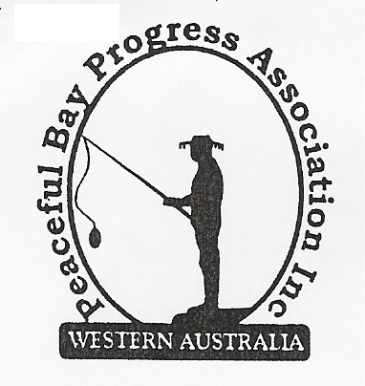

Meeting Opened: 9.05am

Present: Hayden Jones (President), Reg Radford (Vice-President) Katie Eddington (Treasurer), Graeme Liddelow, Margaret Broun, Tony Armstrong, Christine Toovey, Community member – Janine Phillips
Apologies: Mavis Jones, Gill Irvine, Lorraine McNamara, Kelli Ellison

1. Confirmation of Minutes from previous meeting 7 August, 2022

Moved: Katie Eddington 2nd Graeme Liddelow – Accepted and carried by all.

2. Business Arising: All items covered in general business.

3. Correspondence:
IN:
08 Aug – email from Claire Thompson with responses to comments on draft lease.
09 Aug – email from Molly Smith enquiring about progress of staggered leases.
11 Aug – email Kathleen Whitfield requesting further information of signage locations.
14 Aug – email from Microsoft 365 advising our 1 year subscription has been renewed
23 Aug – email from Kristie Buss SoD Council minutes 16 August are on the website.
29 Aug – email from SoD with flyer for locality meeting in Nornalup on 27 September.
OUT:
08 Aug – emailed David Schober accepting the Peaceful Bay Lease Renewal Policy.
10 Aug - emailed David Schober with comments on Draft lease.
10 Aug – email reply to Molly Smith.
11 Aug – email to Kathleen Whitfield SoD re signage locations.

Moved: Hayden Jones 2nd Katie Eddington - Accepted/Endorsed.

4. Finance Report:
All proceeding to budget.
Moved: Katie Eddington 2nd Margaret Broun - Accepted/Endorsed

5. Maintenance Report:
Kitchen Update – Margaret and John to provide tiles for splashback. Thank you to both of you
for progressing the kitchen. Hopefully all finished by next meeting.

6. General Business:
- Signage Proposal Locations. Signage should be erected soon. Advised Shire of Denmark that directional arrows needed to be reversed.
- Draft Peaceful Bay Lease – Community member Janine Phillips provided a resolution by the Shire dated 2014 indicating the cottages can be let out. After discussion, it was agreed to write to the Shire and request clarification.
- Green Waste/Tip update – Hayden spoke with Greg Paape regarding green waste push up. David King notified Hayden that SCEGS will no longer be running the Peaceful Bay Tip. Council worker to fill in. Possible green waste option to be at tip site with 24/7 access.

7. Other Business: Nil

8. Meeting closed: 10.45 Next Meeting: 2nd OCTOBER, 2022

