PEACEFUL BAY PROGRESS ASSOCIATION INC  Peaceful Bay WA 6333  ABN: 54389092839 www.peacefulbayprogress.org.au  Committee Meeting Minutes  for Sunday 2 October, 2022 | 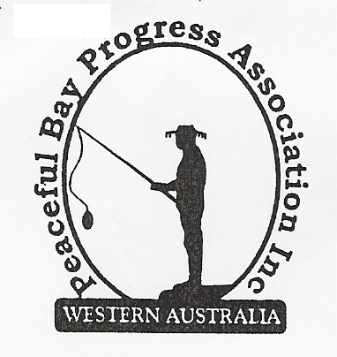

Meeting Opened: 9.00 am

Present: Hayden Jones (President), Katie Eddington (Treasurer), Mavis Jones (Secretary), Lorraine McNamara, Margaret Broun, Chris Toovey, Kelli Allison, Gill Irvine, Tony Armstrong, (Graeme Liddelow – by phone)

Apologies: Kimiora McCarthy, Reg Radford, Cr Phillips

1. Confirmation of Minutes from previous meeting 11 September, 2022

Moved: Graeme Liddelow 2nd Chris Toovey – Accepted and carried by all.

2. Business Arising: All items covered in general business.

3. Correspondence:

IN:
22 Sept – email from Paul Harris re Hall booking in November 2022 and in 2023 for Bibbi Track
25th Anniversary Walk

OUT:
29 Sept – emailed letter to David Schober re Draft Lease.
29 Sept – emailed letter to Gail Guthrie, RSL re Hall bookings to go through Katie.
29 Sept – email reply to Paul Harris confirming receipt of his Hall bookings.

Moved: Mavis Jones 2nd Katie Eddington - Accepted/Endorsed.

4. Finance Report:
All proceeding to budget. Funding has been applied for as usual and waiting for response.

Moved: Katie Eddington 2nd Hayden Jones - Accepted/Endorsed

5. Maintenance Report:

The Oval bore will need major repairs or more likely need replacing in the near future.
Hayden will assess its condition and report back to the committee.
Dust Suppressant We agreed to write to the Shire of Denmark and enquire if this programme
will continue this year.
Hall Kitchen upgrade. John and Margaret Broun have provided and fixed the tiles to the wall
behind the cupboards and it looks great. They have also fitted the kickboards. Thanks again.

6. General Business:

- Draft Peaceful Bay Lease – The progress has been successful in securing the staggered 21 year lease upon sale, bequeathment and capital improvement and the Lease Renewal Policy has been accepted. However, the hold up with the Draft Lease will need to be resolved before both documents can proceed to Council.
- December Newsletter – This will be compiled in November and due to the high cost of postage it was decided that only financial members of the Association will receive a posted copy. Members on the email list will receive an electronic copy. Input from local groups is welcomed i.e. Fire Brigade, Sea Rescue and the RSL.

7. Other Business:

Vale Ray Walker. It is with great sadness that we acknowledge the passing of Ray Walker on Tuesday 27 September. Ray was a staunch supporter of the Peaceful Bay branch of the RSL, local Fire Brigade, drove the RSL bus to Denmark and Albany and was responsible for the maintenance of the vehicle, ‘Jean’s Bus’. He will be very much missed by the Peaceful Bay community. A card delivered Jo on behalf of the Progress Association with our condolences on the loss of Ray.

- Margaret advised that Karis Aplin, Shire of Denmark Sport and Recreation Officer visited the Bay and looked at the Oval regarding siting the Gym equipment we have acquired and offered ideas on sourcing funding to have it installed. She suggested siting 3 or 4 pieces initially. Margaret is heading the Sub Committee overseeing this project.

- Hayden - With the onset of the bush fire season Hayden suggested an informal gathering of volunteer groups to discuss the current state of play in relation to planned burns and evacuation needs in the Bay.

- Katie advised the Defibrillator has been checked and a new battery and pads fitted by an ambulance officer from the Denmark St John Sub station at no charge. A letter of thanks will be sent to St Johns in Denmark. Katie suggested a second Defibrillator would be beneficial at the Sea Rescue Building but St John’s said there was no funding. Chris will follow up with Mandy at St Johns in Albany to see if one can be relocated from a site where it is no longer in use.

- Chris has sourced hinge pins for the bin lids for the Progress.

- Tony expressed concern about speed and visibility at the island roundabout on 5th Avenue as kids come down the hill and on to the road.

8. Meeting closed: 9.55am Next Meeting: 6th NOVEMBER , 2022

