PEACEFUL BAY PROGRESS ASSOCIATION INC  Peaceful Bay WA 6333  ABN: 54389092839 www.peacefulbayprogress.org.au  Committee Meeting Minutes  for Sunday 2 April, 2023 | 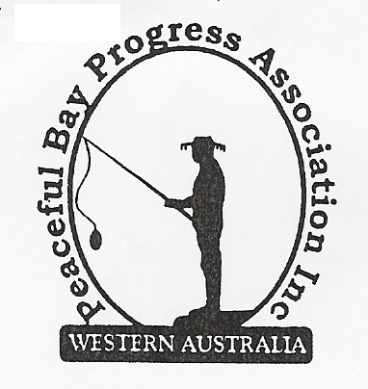

Meeting Opened: 9.03 am.

Present: Hayden Jones (President), Katie Eddington (Treasurer), Mavis Jones (Secretary), Lorraine McNamara, Jude Ottaway, Bronwyn Croghan, Margaret Broun, Gill Irvine

Apologies: Christine Toovey, Graeme Liddelow, Reg Radford

1. Confirmation of Minutes from previous meeting 5 March, 2023
Moved: Lorraine McNamara 2nd Bron Croghan – Accepted and carried by all.

2. Business Arising: All items covered in general business.

3. Correspondence:
IN:
07 Mar – email acknowledged by Steve Sertis Bibbi Track events manager. Out of Office.
07 Mar – email from Paul Harris response to letter sent by PBPA.
08 Mar – email from Paul Harris re communications.
08 Mar – email response from Karis Aplin re exercise equipment funding.
08 Mar – email from Claire Thompson – Audit Advisory Committee meeting Friday 10 March.
14 Mar – email from SoD with flyer re Locality Meeting at Peaceful Bay on Tuesday 11 April.
14 Mar – email from Paul Harris re flyer. He sent his apology.
17 Mar – email from Microsoft re our subscription for our Microsoft 365 Personal programme,
23 Mar – email from Claire Thompson Ordinary Council Meeting minutes 21 March on website.
23 Mar – email from Courtney Walsh SoD re RSVP closing for Workshops today.
27 Mar – email from Rosemarie Arnephie re Citizen of the Year nominations closing 31 March.
28 Mar – email from Martin Buczat re road signage requested by PBPA.
28 Mar – email from Ruby Hughes Denmark Arts Centre re School Holiday workshops in Denmark
28 Mar – email from Jude Ottaway re PBPA Website.
31 Mar – email from Martin Buczak re 4 way junction signage.
01 Apr – email from Joel Rowe re Peaceful Bay Number Plates.

OUT:
07 Mar – emailed a letter to Paul Harris and Bibbi Track association re 25th Anniversary Walk
Bibbulmun Track BBQ and derogatory comments made about the PBPA committee.
07 Mar – emailed a letter of thanks to David King for the Site visit regarding beach access.
07 Mar – email sent by Margaret Broun to Karis Aplin re exercise equipment project.
08 Mar – emailed forwarded to committee re Audit Advisory Committee meeting 10 March.
08 Mar – emailed 2 x email acknowledgments to Paul Harris.
14 Mar – emailed letter to David King re Ring Road, 4 Way Junctions, Reduce Speed signs.
14 Mar – emailed Locality Meeting at Peaceful Bay Flyer - 11 April to members on email list.
19 Mar – emailed 5 March PBPA meeting minutes to Committee.
26 Mar – emailed Locality Meeting Flyer to committee members.

Moved: Margaret Broun 2nd Katie Eddington - Accepted/Endorsed.

4. Finance Report:
All proceeding to budget. The Workers Compensation policy covering Jeremy has been paid
and the Progress will receive a refund when Jeremy is established with the Shire.

Moved: Katie Eddington 2nd Bron Croghan - Accepted/Endorsed

5. Maintenance Report:
- Gill reported the Gazebo on the oval is beginning to show signs of rust. Gill will raise a Works Order with the Shire of Denmark.
- Margaret reported the Beach Access sign is still with the Shire and will raise a Works Order to get it replaced.
- The broken swing at the Playground has been replaced. The other one is showing signs of wear.

6. General Business:
- Fitness equipment – Margaret said the avenues of funding suggested by Karis were found to be not available for this project and other sources need to be found. At meeting of the Sub Committee will be held on Saturday 9 April to discuss progress and look at what types of equipment would be suitable.

- Website - Jude has updated the website with current committee members, events, also some photos and it looks good. Mavis will provide historical meeting minutes. The access codes will be filed and flagged for future reference. Jude has added some photos and it was agreed that she post some photos of the Huts with interesting names (No vehicles or other identifying items will be posted). All information and suggestions will be sent to Jude and we hope it will increase interest in membership if current projects are featured. The paid subscriptions are less than 50%.

- Maintenance Man Position. Mavis spoke to David King at the Shire and he said he would have a JDF and other required paperwork delivered to Jeremy this week and hopefully move this along. We need this to be resolved as it has been dragging out over six months now.

7. Other Business: Nil

8. Meeting closed: 10.20 am Next Meeting: 7TH MAY, 2023

