PEACEFUL BAY PROGRESS ASSOCIATION INC  Peaceful Bay WA 6333  ABN: 54389092839 www.peacefulbayprogress.org.au  Committee Meeting Minutes  for Sunday 7 May, 2023 | 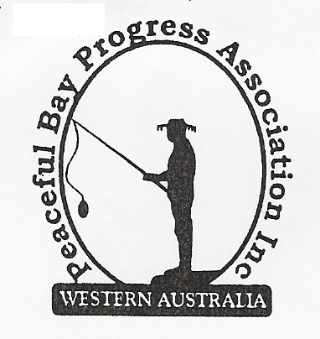

Meeting Opened: 9.02 am.

Present: Hayden Jones (President), Katie Eddington (Treasurer), Mavis Jones (Secretary),
Lorraine McNamara, Christine Toovey, Tony Armstrong, Reg Radford, Gill Irvine,
Jude Ottoway (by phone/TEAM)

Apologies: Bron Croghan, Graeme Liddelow

- Confirmation of Minutes from previous meeting 2nd April, 2023

Moved: Mavis Jones 2nd Katie Eddington – Accepted and carried by all.

2. Business Arising: All items covered in general business.

3. Correspondence:

IN:
06 Apr – email from Claire Thompson – Agenda for the Ordinary Council Meeting on the website.
09 Apr – email from Rick Yeates updating his email address.
10 Apr – email from Kath and Brian Adams updating their email address.
11 Apr – email from Reg re progress of TEAMS and purchase of Jabra speaker.
12 Apr – email from Marie Broadhurst and Donna Haynes updating their email address.
26 Apr – email from Claire Thompson – Minutes from Council meeting 18 April on the website.
27 Apr – email from Debtors at Shire of Denmark with Invoice for rental of Hall site.
02 May – email from Rosie Arnephie with invitation to Volunteer Appreciation Sundowner.
05 May – email from Nicole Phillips re Shire of Denmark/Land Insight workshop to review Coastal
Reserves Management Plan.
05 May – email from Bron advising her apology for May 7 meeting.
05 May – 2 emails from Claire Thompson – advising Special Meeting Agenda 9 May and Ordinary
Council meeting Agenda 16 May on the website.
OUT:
12 Apr – emailed Meeting Minutes to Committee.
12 Apr – emailed Historic minutes and Newsletters to Jude for inclusion on PBPA Website.

Moved: Hayden Jones 2nd Tony Armstrong - Accepted/Endorsed.

4. Finance Report:
All proceeding to budget.

Jeremy started as a Shire of Denmark employee on 1st May and is happy with the move.
The manner of his work will not change and he will continue to have the Bay looking good.
We agreed to send a letter acknowledging his service to the community along with a bonus, ideas on what this should comprise be to be brought to the next meeting.

The Containers for Cash recycling program is continuing to raise funds for the Progress, $145.00 for the month of April.

Moved: Katie Eddington 2nd Lorraine McNamara - Accepted/Endorsed

5. Maintenance Report:

- The current Toilet sign at the Sea Rescue carpark will be relocated and it was agreed to
source a more relevant sign “No toilet facilities here. Nearest toilets located at swim beach
carpark. 500m” to be sited at the carpark. Hayden to follow up.

- Attention was brought to the fact that the Information Bay has no local map or information
pertinent to Peaceful Bay. It was agreed to write to the Shire of Denmark and ask if local
information can be added on the side panels for the tourists and visitors to the Bay.

6. General Business:

TEAM. This was put in place and Jude and Bron will now be able to take part in the monthly
committee meetings via this system. The Jabra speaker will be stored in the Office. Thank
you Reg for facilitating this resource.

7. Other Business:

Tony – The flagpole at the Hall is looking tired and has some rust appearing. He is happy to restore and repaint it. Margaret said she can source a WA Flag to raise on it.

Margaret – advised she will be unavailable to assist with progressing the Fitness equipment project for a short while due to personal commitments.

Jude said she would be happy to do another leaflet drop to encourage subs etc. if needed.

Hayden – we need to keep the gravel road repairs and dust suppressant application flagged with the Shire so these items don’t get overlooked in their budget and maintenance schedules. Keep up the profile. A letter will be sent to the Shire regarding this item.

Mavis – Thank you to Gill and Bron for the Notice Board upgrade. It looks great with the photos and bright banners and will attract the attention of people passing by.

8. Meeting closed: 9.45 am. Next Meeting: 4TH JUNE, 2023

