PEACEFUL BAY PROGRESS ASSOCIATION INC  Peaceful Bay WA 6333  ABN: 54389092839  ANNUAL GENERAL MEETING MINUTES  SATURDAY 2nd JANUARY 2021 | 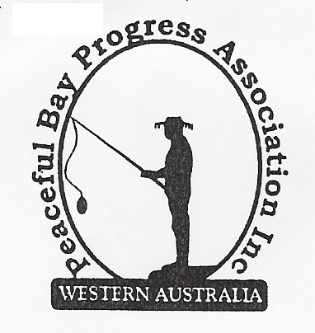

Time opened: 7.35 pm

Present: Attendees to add name to Attendee List provided. 20 members listed.
All attending signed in the COVID-19 Contact Tracing register – Name & phone No.
Apologies: Brian Jones, Tony Armstrong, Callum Baxter.
(Late apologies on Sunday 3rd Michael Thorpe and Janine Phillips)

1. Confirmation of AGM Minutes from 4th January 2020 meeting.
The previous AGM minutes were tabled and read by the Secretary for confirmation.
Moved: Mavis Jones Seconded: Graeme Liddelow- Accepted by All

2. Business Arising
All items to be covered in General Business

3. President’s Report
Hayden Jones (President) presented his report to the meeting encompassing all the
activities and projects undertaken by the Committee throughout the year.
(A copy attached).
Moved: Hayden Jones Seconded: Leanne Taylor - Accepted by All

4. Finance & Audit Report
Katie Eddington (Treasurer) tabled the Audit Report for the year 1 November, 2019 to 31
October, 2020 from Auditor Dot Ruck.
Moved: Katie Eddington Seconded: Dot Kleeman - Accepted by all
Dot Ruck was appointed Auditor for next financial year.
Moved: Hayden Jones Seconded: Reg Radford - Accepted by all

5. Election of Office Bearers
Returning Officer: Lisa Jones
All positions were declared vacant and nominations were called. The results are recorded on the attached Sheet.
Hayden Jones (President), Reg Radford (Vice President), Katie Eddington (Treasurer), Mavis Jones (Secretary), Committee members: Leanne Taylor, Graeme Liddelow, Tony Armstrong, Lorraine McNamara, Janine Phillips (in absentia). Thank you to all volunteers for accepting these roles. Janine to confirm her acceptance at the next Committee meeting.

6. Subscription Amount for 2021/2022 Period
A suggestion was put forward to raise the Subs to $25.00. This is the first increase in quite
a number of years and it was felt we needed to keep pace with increasing costs.
Moved: Dot Kleeman Seconded: Lisa Jones - Accepted by all

7. General Business:

Staggered Leases: Advice from the Shire of Denmark is that Councillors have been provided with an overview of the proposal and they are generally amenable to the idea, subject to the detail. The detail and process will be progressed further in the New Year and the Association will be contacted to run through the proposal. At this stage, the Shire cannot be more specific on timing. The committee will keep in contact with the Shire for updates.

Registering of Leases. This was raised for clarification and it was explained that the Shire of Denmark does not register leases with Landgate. But, it is recommended that Lessees register their leases with Landgate as another layer of security of tenure as the certificate confirms that the Lessee has a vested interest in the lease. The process can begin by the Lessee contacting Landgate.

Reserve Fund. The PPBA was invited by the Shire of Denmark to request the percentage of lease money we wish to see put aside and we decided that 25% initial contribution with annual increments of 5% was reasonable and advised the Shire. We also requested a change of name for the Fund to specifically identify what the money in the Fund was for, which is primarily sewerage if it ever becomes an issue in the future, which means this fund cannot then be used for general infrastructure in the Bay which should come out of annual rates.

8. Other Business:

Dust Suppression. The Shire of Denmark laid down the dust suppression compound on the gravel roads the week before Christmas and so far community members are pleased with the result. Reg suggested we put an item on the Peaceful Bay Facebook Page to encourage feedback which we can then pass on to the Shire for use in planning to make it an annual maintenance item with allocated funding and also advise that the suppressant used is Dustex which is a wood pulp derivative and is environmentally friendly.

Speed Signage. The Shire of Denmark has erected “10 k/ph Shared Zone” signs on the village roads and they have been very well received. Comments indicate that they are effectively slowing down vehicles. Although it was acknowledged that there will always be thoughtless, selfish drivers who don’t think it applies to them.

Christmas Party and Fun Day. The Christmas Party was well supported and all in attendance enjoyed the festivities. The Fun Day was equally successful and the crowd appreciated the effort put in to make the day a lot of fun for everyone. The earlier start time of 11.00 appeared to suit a lot of families as they were able to have lunch, a very good time and still have time at the end of the day to do something else or go home and rest.

Dot Kleeman commended the Peaceful Bay Progress Association Committee for all they have achieved this year. Their efforts were applauded by all in attendance.

Time Closed: 8.20

Next AGM meeting: January, 2022 – date to be advised

Next Committee Meeting: Sunday 3rd January, 2021

