PEACEFUL BAY PROGRESS ASSOCIATION INC  Peaceful Bay WA 6333  ABN: 54389092839  ANNUAL GENERAL MEETING MINUTES  SATURDAY 8th JANUARY 2022 | 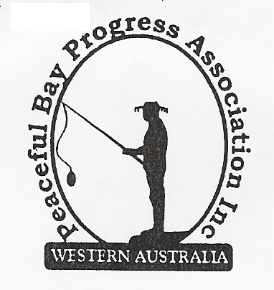

Time opened: 7.30 pm

Present: Attendees to add name to Attendee List provided.
All attending signed in the COVID-19 Contact Tracing register – Name & phone No.

Apologies: Brian Jones, Lisa Jones, Tony Armstrong, Christine and John McConigley, Leanne
Taylor, Graeme Liddelow.

1. Confirmation of AGM Minutes from 2nd January 2021 meeting.
The previous AGM minutes were tabled and read by the Secretary for confirmation.
Moved: Reg Radford Seconded: Katie Eddington - Accepted by All

2. Business Arising
All items to be covered in General Business

3. President’s Report
Hayden Jones (President) presented his report to the meeting encompassing all the
activities and projects undertaken by the Committee throughout the year.
(A copy attached).
Moved: Hayden Jones Seconded: Reg Radford - Accepted by All

4. Finance & Audit Report
Katie Eddington (Treasurer) tabled the Audit Report for the year 1 November, 2020 to 31
October, 2021 from Auditor Dot Ruck.
Moved: Katie Eddington Seconded: Margaret Eggington - Accepted by all
Dot Ruck was appointed Auditor for next financial year.
Moved: Hayden Jones Seconded: Lorraine McNamara - Accepted by all

5. Election of Office Bearers
Returning Officer: Margaret Broun
All positions were declared vacant and nominations were called. The results are recorded on the attached Sheet.
Hayden Jones (President), Reg Radford (Vice President), Katie Eddington (Treasurer), Mavis Jones (Secretary), Committee members: Leanne Taylor, Graeme Liddelow, Tony Armstrong, Gill Irvine, Keli Allison, Kimiora McCarthy, Margaret Broun, Christine Toovey, Lorraine McNamara. Thank you to all volunteers for accepting these roles.

6. Subscription Amount for 2022/2023 Period
It was agreed to keep the Subscription amount at $25.00 for the next financial period.

Moved: Hayden Jones Seconded: Reg Raford - Accepted by all

7. General Business:

Staggered Leases: Advice from the Shire of Denmark is that a new lease document for a 21 year lease should be finalised through solicitors and will most likely go before Council in February, 2022.

Dust Suppression. The dust suppressant was applied this year, but due to an error by the operators it was not very successful and most of the suppressant did not end up on the gravel road. The Progress will confirm the 2022 application will go ahead in November.

Christmas Party and Fun Day. The Christmas Party was well supported again this year and all in attendance enjoyed the festivities. The Fun Day was equally successful and the crowd appreciated the effort put in to make the day a lot of fun for everyone. Thank you to those who assisted on the day, however, more volunteers are desperately needed for the Fun Day to ease the load on the same few.

Beach Access Platform and Steps. Advice from the Shire of Denmark is that funding has been approved this financial year to replace the platform and steps, however they are unable to secure a contractor to undertake the work. In the meantime, the Association has been asked to seek contractors through our members and contact the Shire if any are available.

8. Other Business:

Margaret Broun asked about roadside slashing, as the bush is encroaching on the road in places in Peppermint Way. Also, the drains need cleaning out and maintaining. It was agreed to write to the Shire and inquire if this maintenance is scheduled for this year.

Janine Phillips advised that the new Council Representative for Nornalup/Kent is Jackie Ormsby and to please contact her if information or assistance is needed. The Peaceful Bay Road is due for the final seal around Easter. The Reserve Fund is before Council in March.
The Shire of Denmark has acknowledged that the dust suppressant application was Council workers fault and a review of all gravel roads in the area, including Peaceful Bay will be done in April-May.

Time Closed: 8.25 pm

Next AGM meeting: January, 2023 – date to be advised

Next Committee Meeting: Sunday 9th January, 2022

